CS-360-T5539 Mobile Architect & Programming 23EW5

3-2 Assignment: Android Studio Introduction

Jacob Simmons, 20 May 2023

**Screenshots**

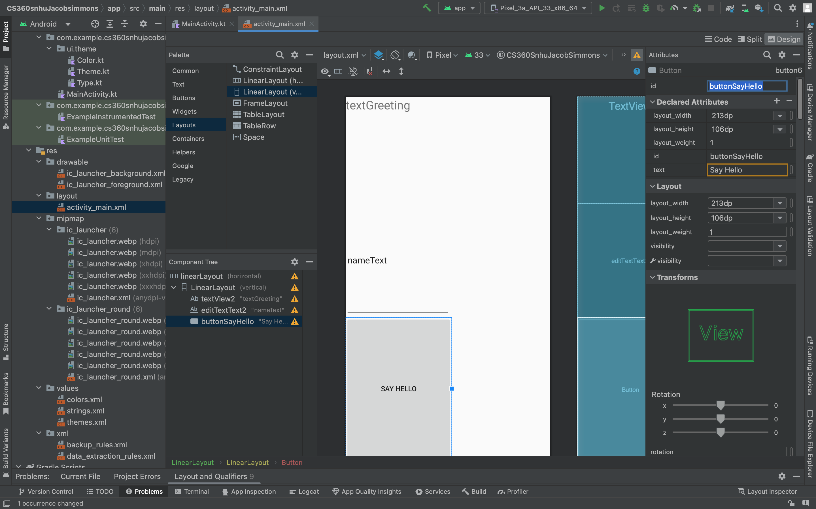

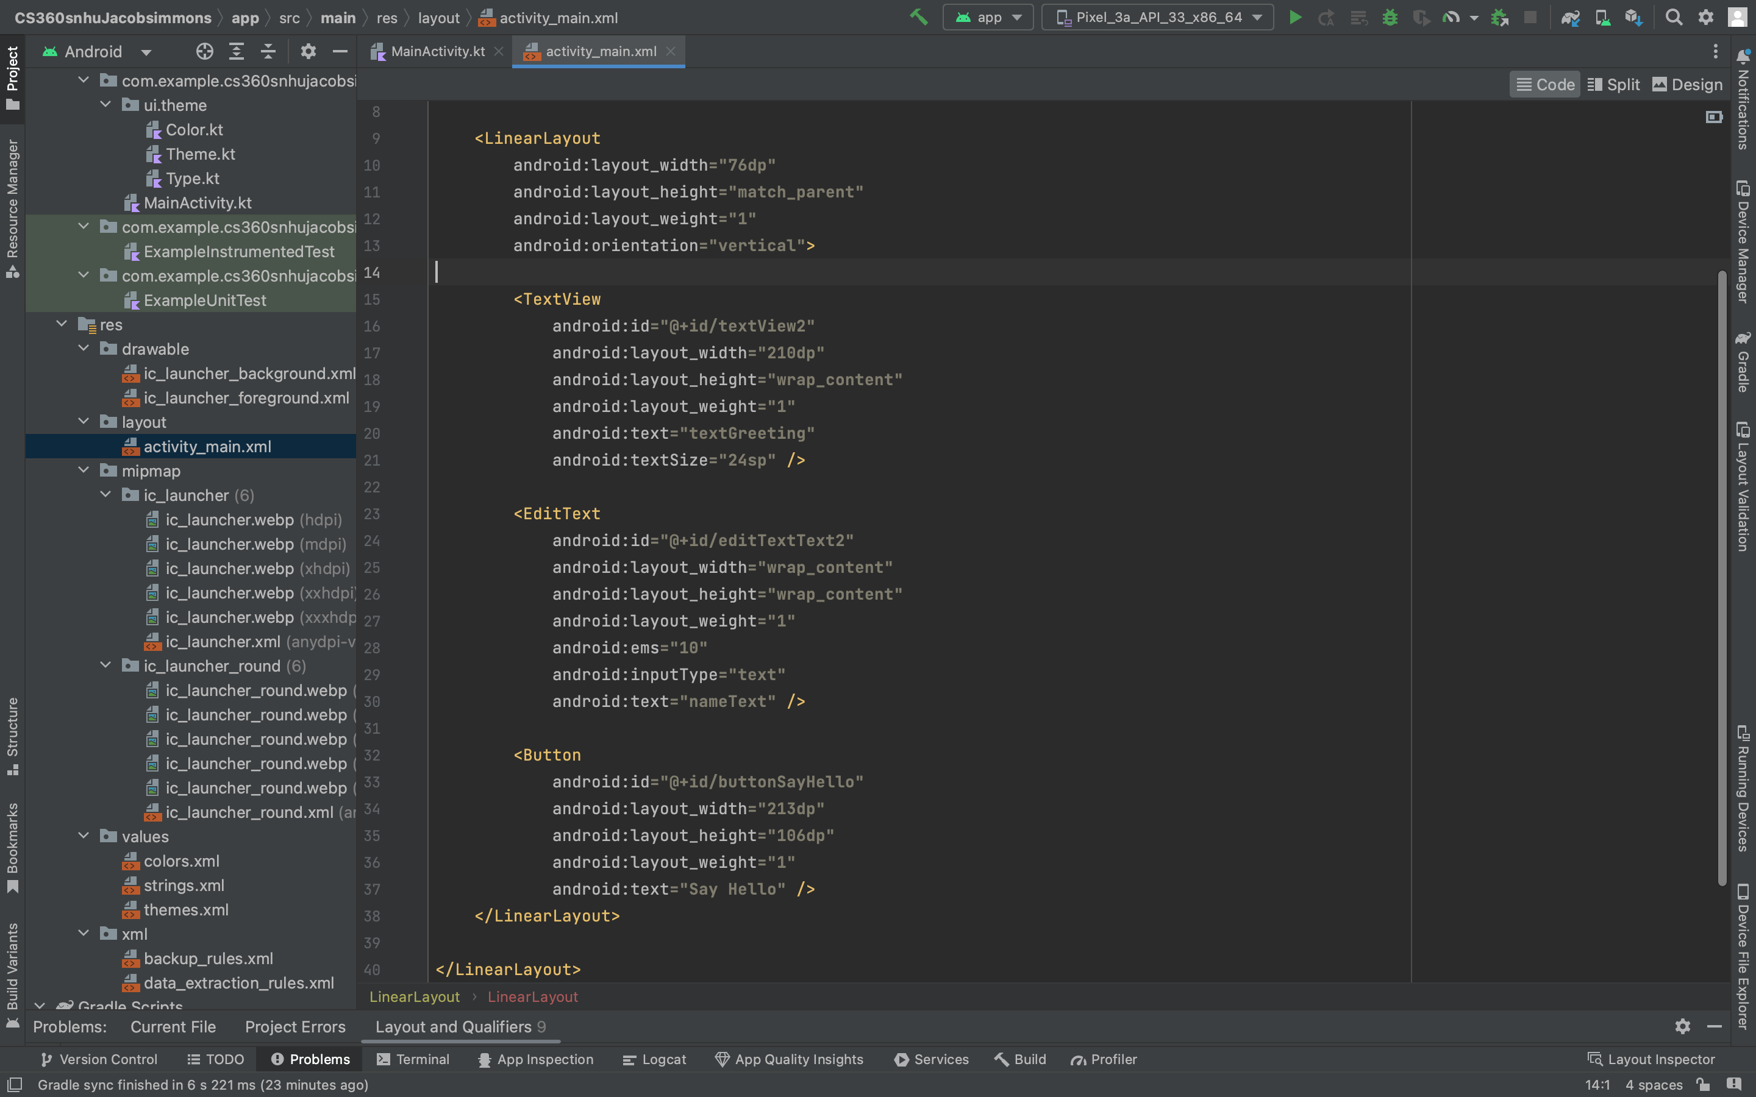

**Challenge Discussion**

The main challenge with this project was related to the viewing the layout folder in the "res" folder. This was not initially viewable when the project was created. I had to research online to determine this as an item I needed to add in the package after the project was created. This allowed me to edit the file as needed for the assignment.

There are still more challenges that I need to overcome related to the layouts. I was able to use a layout that was unique and "custom", however I need to use this software more to understand the features to a deeper level to ensure I am able to make an aesthetically pleasing application.

The layout tool is a great way to quickly speed up the process of creating a user interface, however there are still many nuances that should be understood as it relates to layout, naming conventions, object use and intent, and general experience of application design. The material covered in ZyBooks as it related to layout is useful as a reference source. There is a lot of material that we have covered thus far throughout the course and it was valuable to reference that material when creating this UI.